**Project Design Phase II**

**Technology Stack (Architecture & Stack)**

|  |  |
| --- | --- |
| Date | 15 October 2022 |
| Team ID | PNT2022TMID24762 |
| Project Name | Project-Signs with Smart Connectivity for Better Safety |
| Maximum Marks | 4 Marks |

**Technical Structure:**

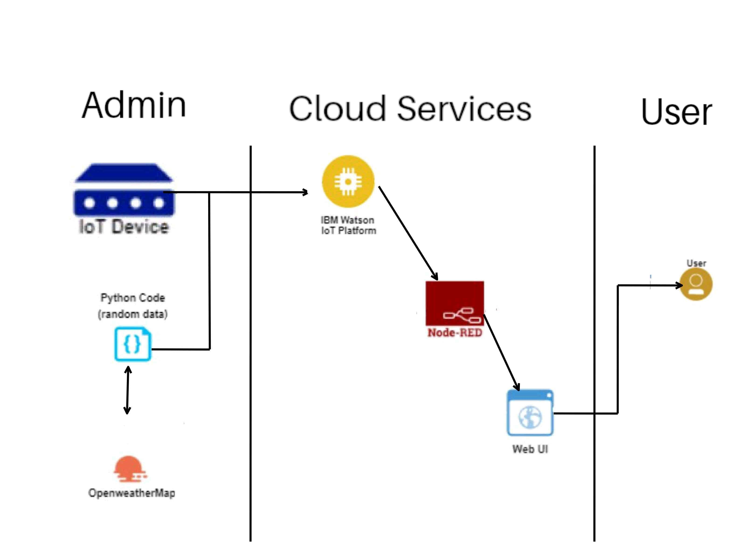

|  |  |
| --- | --- |
|  | **GUIDELINES:**   * Smart Connectivity based signboards are used to replace static signboards.   •   * Based on situations, like high traffic, construction or branch on the road etc the diversion signs are changed.   •   * Sign boards in the vicinity of schools, hospitals, restaurants etc have signs displayed accordingly.   •   * Speed limitations can be sent through a web app, which gets weather conditions from weather API and changed in the signboards.   •   * Many different operation can be updated like finding the number of passengers in a vehicle, helps in finding stolen vehicles easily. |

|  |  |  |  |
| --- | --- | --- | --- |
| **S.NO** | **Component** | **Description** | **Technology** |
| 1 | User Interface | In what way the user interacts  with the application, in this  case Web UI app | Javascript, HTML,CSS |
| 2 | Application Logic -2 | A logic for the process in the application | IBM Watson STT Service |
| 3 | Application Logic-3 | A logic for the process application | IBM Watson Assistent |
| 4 | Cloud Database | Cloud which has database service | IBM DB2,IBM Cloudant |
| 5 | External API-1 | Purpose of external API in the application | IBM Weather API |

**Table-1: Components & Technologies**

**Table-2: Application Characteristics**

|  |  |  |  |
| --- | --- | --- | --- |
| **S.NO** | **Characteristics** | **Description** | **Technology** |
| 1 | Security  Implementations | A very strong security system where no one will be able access without login credentials | Firebase. Firewall, Cyber resiliency strategy |
| 2 | Scalable Architecture | By increasing the bandwidth, the operating range can be increased | IoT,Internet |
| 3 | Availability | Available 24/7 | IBM Cloud |
| 4 | Performance | It can support a large amount of users to access the technology | IBM Cloud |